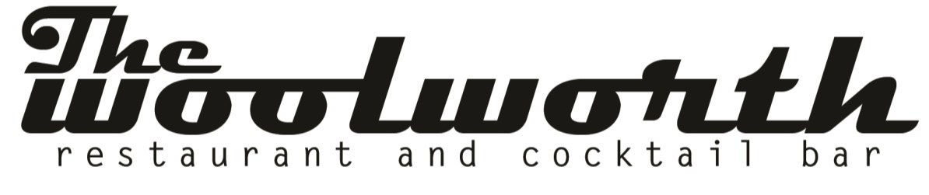
Brunch Platters

Fruit & Yogurt Parfait Shooters* (25 each) 75
Vanilla yogurt, mixed berry, granola

Fruit Tray* (serves 24) 95
Seasonal fruit Selection

Deviled Eggs* (48 each) 75
Classic recipe, dijon mustard, mayonnaise, paprika

Bite Site Quiche (50 each) 55
Assorted mini quiche bites

Coffee Cake* (25 each) 45
Sour cream coffee cake, cinnamon, brown sugar, nuts

The Brunch Buffet
Buffets are designed to accommodate a guaranteed guest count and are not “all you can eat”
Additional charges will be applied for extra food and must be purchased in advance.

All brunch buffet packages are priced per person

Brunch Buffet 1: Choice of 2 entrees, 2 sides, 1 dessert 20

Brunch Buffet 2: Choice of 3 entrees, 3 sides, 1 dessert 25

Brunch Entrees:
Breakfast Tacos – Egg, potato, and cheddar on flour tortilla
Healthy Choice Scramble – Egg whites, wild mushroom, tomato, goats cheese, spinach
America Scramble – Scrambled Eggs, Cheddar Cheese, Sausage, Bacon
Migas – Scrambled eggs, chorizo, smoked gouda cheese, red chili tomatillo sauce, corn tortillas and pico
French Toast - Rich egg custard, pasano bread
B & G - Buttermilk biscuits topped with a sausage and bacon peppered cream gravy

Brunch Sides:
Southwestern Potatoes - red skin potatoes tossed with bell peppers, onions and roasted jalapenos
Fruit Skewers-Mixed fruit with marshmallow cream
Breakfast Meats - Bacon / sausage patties / country ham
Homemade Biscuits with Butter and Berry Compote ***Add Peppered Gravy $2/person

Sweet Street:
Smash Cake – Chocolate cake, cookie crumb, chocolate ganache, expresso shot, fudge icing
Caramel Boudino – Crushed chocolate cookies, vanilla anglaise, salted caramel sauce, chantilly cream
Crème Brulee-Amaretto custard, fresh berries, crystalized sugar, crispy chocolate pearls

