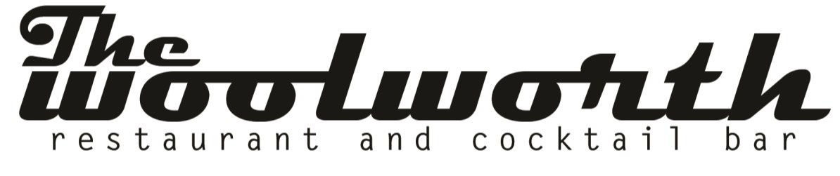
The Dinner Buffet
Buffets are designed to accommodate a guaranteed guest count and are not “all you can eat”
Additional charges will be applied for extra food and must be purchased in advance.
**Add Bread & Butter Service for $3/guest
**Add Fruit & Nut for $4/guest

Buffet 1: Choice of 2 entrees, 2 sides, 1 dessert 45

Buffet 2: Choice of 3 entrees, 3 sides, 1 dessert 55

Buffet 3: Choice of 3 entrees, 4 sides, fruit & nut, 1 dessert 65

Chef Entrees:
Monterey Chicken
Grilled chicken breast, Carolina BBQ sauce, broccoli, white cheddar cheese

Pan Seared Scallops with Marsala Jus
Jumbo U-8 wild scallops, salt & pepper crust, marsala jus

Fresh Catch
Char broiled, cajun spices, mango relish

Jumbo Prawns with Sundried Tomato Pesto (limit 3 each per person)
Mesquite grilled, pea shoot pesto, sundried tomato tapenade

Herb Crusted Ribeye Slow Roasted with Vegetable Jus
Slow roasted, vegetable jus, horseradish cream

Grilled Filet Mignon ($5 extra per person)
Flame grilled, cracked pepper, sea salt, red wine jus

Short Rib Ragu
Slow braised, wild mushroom, onion, carrot, celery

Chef Sides:
Parmesan Potatoes*
Baked, heavy cream, salt, fresh thyme, pecorino

Yukon Mash*
Butter, sour cream, pecorino

Fingerling Potatoes*
Tri-color potato, roasted garlic, rosemary, sea salt

Stir Fry Vegetables*
Chili oil, green beans, carrot, celery, red pepper, yellow pepper, cashew, miso-saki, toasted sesame

Truffle Mac and Cheese*
Raditori pasta, white truffle oil, melting cheese, breadcrumbs
roasted root vegetables*
sweet potato, carrot, parsnip, beet, turnip, maple syrup, balsamic glaze

Succotash*
Carrot, pea, corn, squash, zucchini, red pepper, yellow pepper

French Bean
Haricot verts, caramelized onion, bacon lardon, heirloom tomato

Crispy Asparagus* ($4 extra/person)
Balsamic marinade, bacon wrapped, moody blue cheese

Sweet Street:
Crème Brulee
Amaretto custard, berries, crystalized sugar, crispy chocolate pearls

Caramel Boudino
Crushed chocolate cookies, vanilla anglaise, salted caramel sauce, chantilly cream

Smash Cake
Chocolate cake, cookie crumb, chocolate ganache, espresso shot, fudge icing

OG Cake
Bundt cake, sour cream, vanilla, chocolate chip, powder sugar

